**Call for Papers: *Women, Money and Markets (1750-1850)***

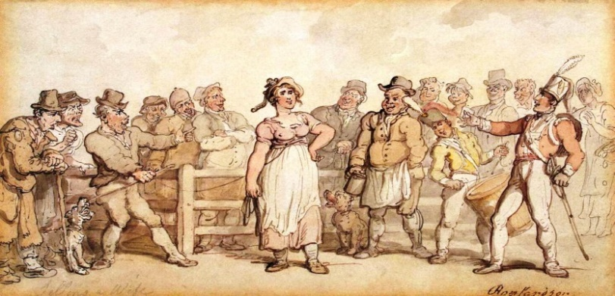

**King’s College London, Thursday May 11th 2017**

**Keynote Speakers:   
*Professor Hannah Barker (University of Manchester)   
Caroline Criado-Perez, OBE***One of the leading voices in the campaign for female representation on the banknote and an active promoter and supporter of women in the media

In 2017, Jane Austen will feature on the £10 note as the sole female representative on British currency. To mark this occasion, and explore its problematic significance, the English department at King’s is running a one-day conference with the aim to consider debates about women in relation to ideas of value, market, marketability, as well as debates about different forms of currency and exchange amongst women, and the place of the female writer in the literary marketplace past and present**.** The conference will address themes including consumerism, shopping, global trade, domestic trade, markets (literary and otherwise), currency, and varying practices of exchange. The conference is interdisciplinary in nature, bridging literature, material culture, gender studies and economic history, and aims to relate the debates of the period to modern day issues about the presence and position of women in the economy and media.

We welcome submissions in the form of individual papers, panels and roundtable discussions on the following themes:

* The varying practices of women associated with currency, global and/or domestic markets and marketability
* Material practices associated with value, exchange and/or female creativity
* Women as producers and/or consumers in the literary or other marketplaces (including, but not limited to, food, clothing, agriculture and raw materials)
* Representations of women at work or women’s involvement in:
  + Trade and industry
  + Professional services (such as law, finance, hospitality and the media)
  + Domestic service
  + The rural economy
* The place of women in the literary marketplace (past and present)

**We particularly welcome cross-cultural considerations of the above issues.**

Please send 300 word abstracts to the conference email address ([womenmoneymarkets@gmail.com](mailto:womenmoneymarkets@gmail.com)) with an indication of your proposed format (individual paper, panel, roundtable, etc.). If you are submitting a proposal for a panel, please include an abstract for each paper (up to 300 words each). *Please indicate if you would like your paper to be considered for the edited volume that will be published after the conference.*

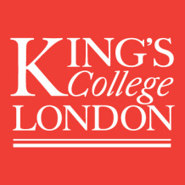**Deadline for submissions:** January 31st 2017 **Conference Organisers:** Dr Emma Newport (University of Sussex) and Amy Murat (King’s College London)

For enquiries regarding the programme, please contact: [emma.newport@kcl.ac.uk](mailto:emma.newport@kcl.ac.uk)   
All general enquiries, please contact: [womenmoneymarkets@gmail.com](mailto:womenmoneymarkets@gmail.com)

The conference is generously supported by CESK (Centre for Enlightenment Studies at King’s) and AHRI (Arts and Humanities Research Institute). <http://www.kcl.ac.uk/artshums/ahri/centres/cesk/index.aspx>